Chapter 3

Structured Methodologies
Introduction
Structured methodologies (or structured systems analysis and design) have been used to document, analyze, and design information systems since the 1970s. Structured refers to the fact that the techniques are step by step, with each step building on the previous one. Structured methodologies are top-down, progressing from the highest, most abstract level to the lowest level of detail – from the general to the specific.
Structured development methods are process-oriented, focusing primarily on modeling the processes, or actions that capture, store, manipulate, and distribute data as the data flow through a system. These methods separate data from processes.
The primary tool for representing a system’s component processes and the flow of data between them is the data flow diagram (DFD). The data flow diagram offers a logical graphic model of information flow, partitioning a system into modules that show manageable levels of detail. It rigorously specifies the processes or transformations that occur within each module and the interfaces that exist between them.
Another tool for structured analysis is a data dictionary, which contains information about individual pieces of data and data groupings within a system. The data dictionary defines the contents of data flows and data stores so that systems builders understand exactly what pieces of data they contain. Process specification is another tool that describes the transformation occurring within the lowest level of data flow diagrams. They express the logic for each process. We can express the logic using structured English, decision table, decision tree etc.
In structured methodology, software design is modeled using hierarchical structure charts. The structure chart is a top-down chart, showing each level of design, its relationship to other levels, and its place in the overall design structure. The design first considers the main function of a program or system, then breaks this function into subfunctions, and decomposes each subfunction until the lowest level of detail has been reached. A structure chart may document one program, one system (a set of programs) or part of one program.
The Need for Structured Methodology
Most information systems development organizations use structured methodology because it offers the following advantages:
- Improve project management & control
- Make more effective use of experienced and inexperienced development staff
- Develop better quality systems with low cost
- Make projects resilient to the loss of staff
- Enable projects to be supported by computer-based tools such as computer-aided software engineering (CASE) systems
- Establish a framework for good communications between participants in a project
- Enable projects to deliver the product on time because it allows to plan, manage and control a project well
- Respond to the changes in the business environment while project progresses
- Improves the overall productivity by encouraging on-time delivery, meeting business requirements, ensuring better quality, and using human resources effectively.
Role of CASE in Data Modeling
Data models are stored in a repository. CASE (computer-aided systems engineering) provides the repository for storing the data models and its detail description. Most CASE tools support computer-assisted data modeling and database design. CASE supports in drawing and maintaining the data models and their underlying details.
Using CASE product, you can easily create professional, readable data models without the use of paper, pencil, erasers, and templates. The models can be easily modified to reflect corrections and changes suggested by end users – you don’t have to start over. Also, most CASE products provide powerful analytical tools that can check your models for mathematical errors, completeness, and consistency. Some CASE products can even help you analyze the data models for consistency, completeness, and flexibility.
Also, some CASE tools support reverse engineering of existing files and database structures into data models. The resulting data models represent physical data models that can be revised and reengineered into a new file or database, or they may be translated into their equivalent logical models. The logical data models could then be edited and forward engineered into a revised physical data model and subsequently a file or database implementations.
Data Dictionaries
It is a structured repository of data. Although we give descriptive names to the data flows and data stores in a DFD, it does not give the details. Hence to keep the details of the contents of data flows and data stores we require a Data Dictionary. Data Dictionary is a structured repository of data. It clearly documents the list of contents of all data flows and data stores. The three concepts to be defined are:
- Data Elements: - This is the smallest unit of data. Further decomposition is not possible. For example, STUDENT_NAME. Each data element has a data type that defines what class of data can be stored in that data element and domain that defines what values a data element can legitimately take on.
- Data Structure: - This is a group of Data Elements which together form as a single unit of a data flow.
- Data flows and Data stores: - Data flows are data structures in motion. Data flows can be described in terms of three types of data structures: sequence (a group of data elements that occur one after another), selection (one or more data elements from a set of data elements), and repetition (one or more data elements). Data Stores are data structures in store.
Modeling Tools
We use different modeling tools to specify detailed logic for the elementary processes on a DFD. Some common tools are Structured English, Decision Table, and Decision Tree.
Structured English
Structured English is a modified form of the English language used to specify the logic of information system processes. It is a language and syntax for specifying the logic of processes based on the relative strengths of structured programming and Natural English. The three constructs of Structured English are discussed below.
- A sequence of simple, declarative sentences-one after another. Compound sentences are discouraged because they frequently create ambiguity.
      - A conditional or decision structure indicates that a process must perform different steps under well-specified conditions. For example,
BEGIN IF
IF Quantity-in-stock is less than Minimum-order-quantity
THEN GENERATE new order
ELSE DO nothing
END IF
      - An iteration or repetition structure specifies that a set of steps should be repeated based on some selected condition. For example,
WHILE NOT End-of-File DO
BEGIN IF
IF Quantity-in-stock is less than Minimum-order-quantity
THEN GENERATE new order
ELSE DO nothing
END IF
END DO
Decision Table
Many processes are governed by complex combinations of conditions that are not easily expressed with structured English. This is most commonly encountered in business policies. In this case, we use decision table.
Decision table is a tabular form of presentation that specifies a set of conditions and their corresponding actions. Decision tables are very useful for specifying complex policies and decision-making rules. Three components of the decision table are:
- Condition stubs (the upper rows) describes the conditions or factors that will affect the decision policy.
- Action stubs (the lower rows) describe, in the form of statements, the possible policy actions or decisions.
- Rules (the columns) describe which actions are to be taken under a specific combination of conditions. Each combination of conditions defines a rule that results in an action, denoted by an X.
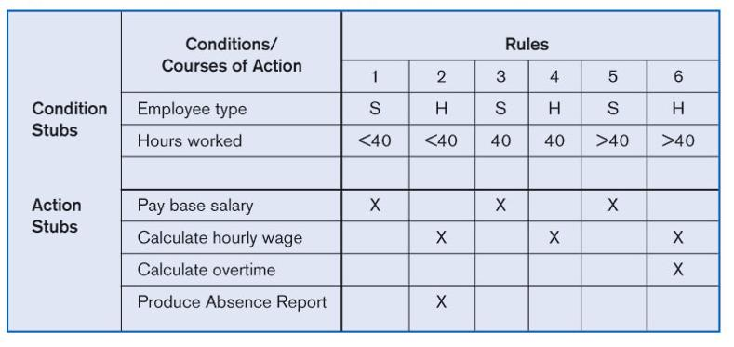
For example, the figure below models the logic of a generic payroll system. The condition stubs contain tow conditions employee type (salarized and hourly) and hours worked (less than 40, exactly 40, and more than 40). The action stub contains four courses of action (pay basic salary, calculate hourly wage, calculate overtime, and produce absence report) that result from combining values of the condition stubs. And there 6 rules (each combination of conditions) that result in actions.
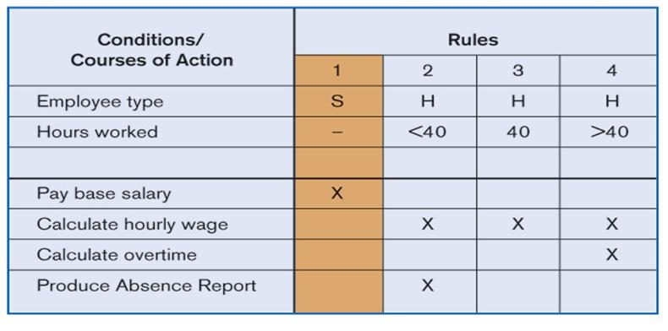
In a decision table, an indifferent condition is a condition whose value does not affect which actions are taken for two or more rules. In the figure above, the number of hours worked does not affect the outcome for Rules 1, 3, and 5. For these rules, hours worked is an indifferent condition. Hence, we can reduce the number of rules by condensing Rules 1, 3, and 5 into one rule as shown in the figure below.
Decision Tree
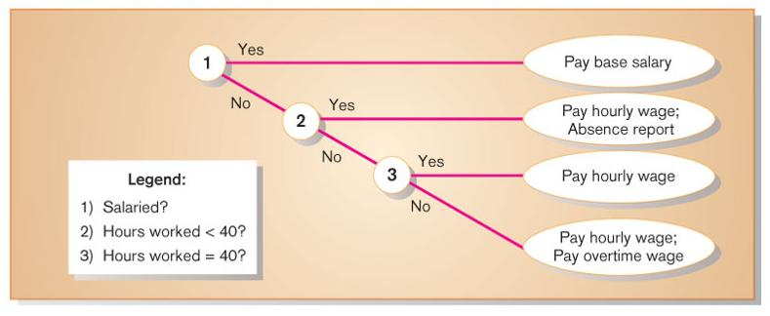
Decision tree is a graphical representation of a decision situation in which decision situation points (nodes) are connected together by arcs (one for each alternative on a decision) and terminate in ovals (the action that is the result of all of the decisions made on the path leading to that oval). The figure below shows the decision tree for the payroll system discussed before.
Advantages and Disadvantages of Modeling
A model is a picture that represents reality. Models can be built for existing systems to better understand the systems or for the purposed systems to document business requirements. We can draw models in different phases during information systems development. Drawing models offers the following advantages:
- Models represent reality of the system that we are going to develop.
- Models are clear to understand and easy to change when requirements change.
- Models reduce the risk of missing business requirements. We can better analyze the requirements for completeness, accuracy, and consistency.
- Models allow us to communicate with end-users in non-technical or less technical languages.
The major disadvantage of models is that, drawing models is a time consuming process. However, we can use CASE tools to draw models easily, quickly, and accurately.

